
AMERICAN INTERNATIONAL UNIVERSITY-BANGLADESH
Faculty of Science and Technology
Department of Computer Science
CSC 3215: Web Technologies

Semester: Summer 2025-26 | Group No:08 |  | Section: | K

Group Members:
SL. | Student ID | Name | Role | Signature
41 | 24-56849-1 | Md. Ashikur Rahman Mirza | Group Leader
37 | 24-56803-1 | Md. Mostafizur Rahman | Member
35 | 24-56776-1 | Shahed Bhuiyan Rony | Member
40 | 24-56826-1 | Shajia Afrin | Member
Project Title
Paw Care – Pet Shop and Veterinary Service Management System
Short Description
Paw Care is a web-based pet shop and veterinary service management system. Which is designed for simplify the pet related services by a single online platform. The system allows customers various services like browse pets and pet products, place orders, book veterinary appointments, and also track deliveries. Here, The System Administrators can manage inventory, users, orders, and business operations very efficiently. On the other hand, the veterinary doctors can organize appointments for pets medical treatments and maintain pet medical records for any further purpose. The main purpose of the system is to provide a secure, user friendly, and efficient digital solution for modern pet care businesses.
Introduction
Nowadays, the pet care industry is growing rapidly day by day, and many pet owners now like to have a convenient online service for purchasing pets, buying necessary pet products, and accessing veterinary care for their lovable pets. Now in the current situation, many pet shops still rely on keeping record manually for their services, which is making it difficult to manage inventory, customer orders, appointments, and others business operations efficiently.
Now, Paw Care is a web-based management system developed for providing an integrated digital platform for pet shops and veterinary services. The system offers customers to explore available pets and products. There are also some key features like place online orders, schedule veterinary appointments, and manage their accounts from anywhere. On the other hand, administrators can monitor business activities, manage inventory, and maintain overall system operations very easily.
Here our main key motive is to combining pet shop management and veterinary services into a single web application and provide a use friendly service to the users. Paw Care improves the service quality and reduces manual work also enhances data organization and provides a better experience for both business owners and customers at a same time.
Background Study
In recent years, web-based business management systems have become more popular, because they provide a faster way to access information and better data management also improved customer experience. The pet care industry is also adopting these digital solutions to simplify business operations and focusing on to provide more customer satisfaction.
Traditional pet shops are maintaining customer records, inventory, veterinary appointments, and sales manually or through various desktop applications. These approaches may be lead them a serious trouble like data redundancy, inefficient workflows, and limited accessibility.
Here, Paw Care is proposed as a web-based solution. Which is integrates pet shop operations, veterinary services, and delivery management into a single platform. By using modern web technologies such as HTML, CSS, JavaScript, PHP, and MySQL, the system offers secure data management, real-time accessibility, and role-based functionalities for different types of users.

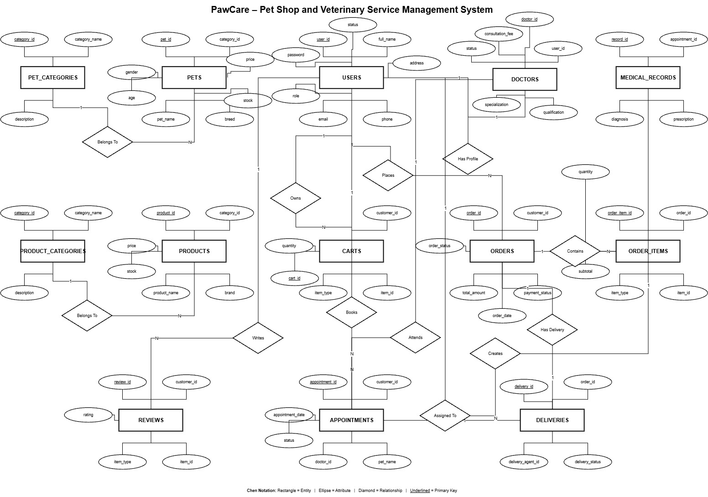
ER Diagram
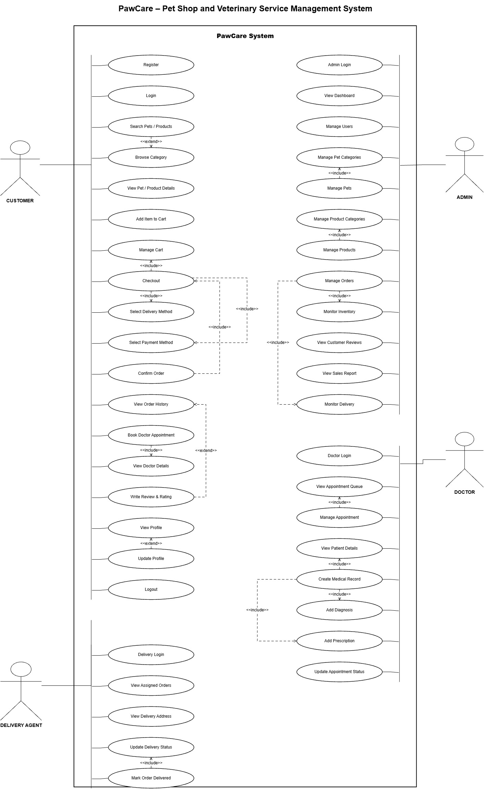
Use Case Diagram
UI (Figma/Sketch)
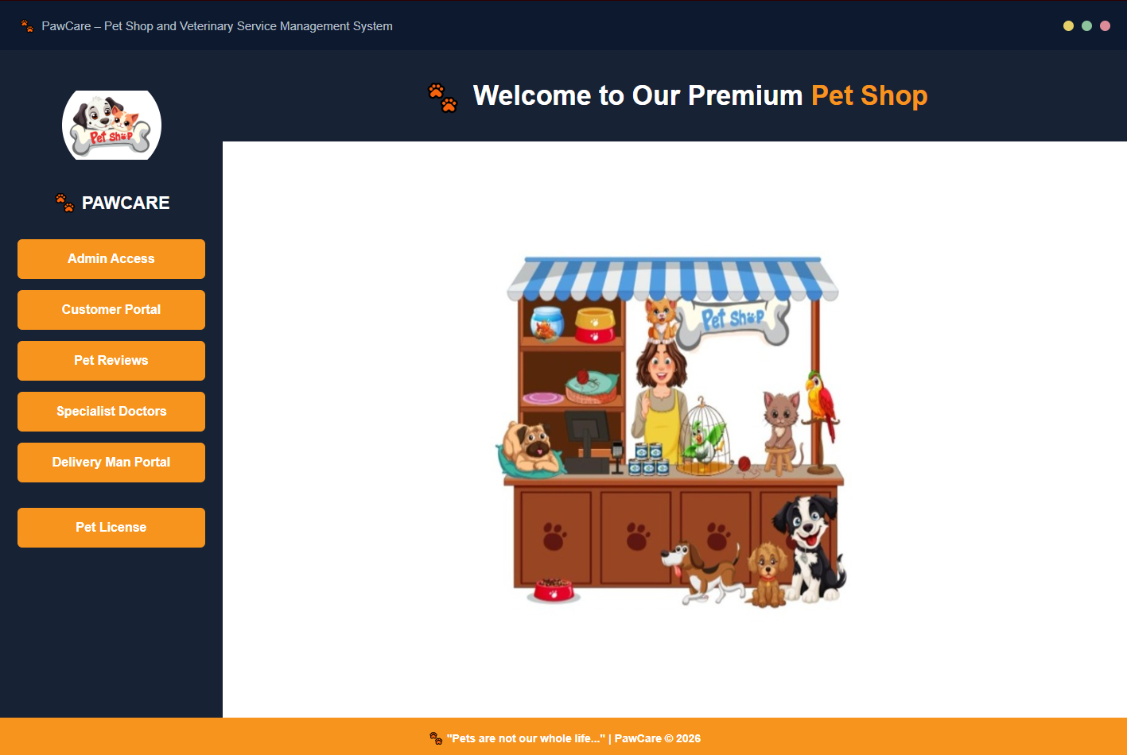
Main Dashboard

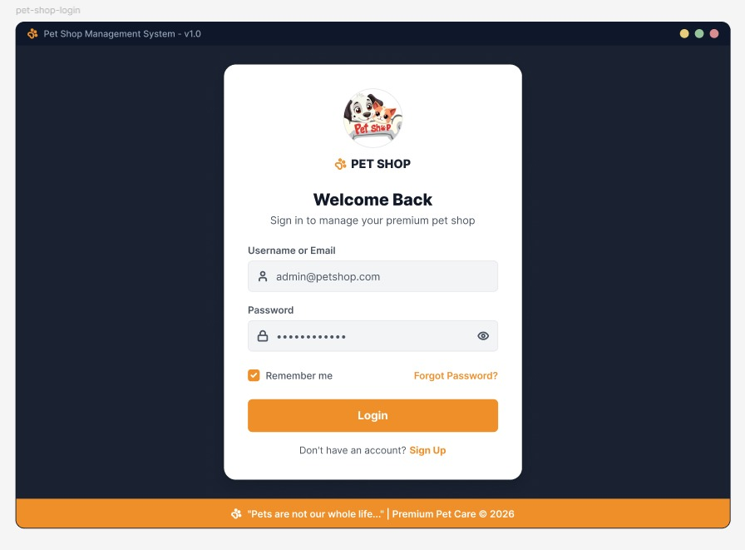
Log in Page
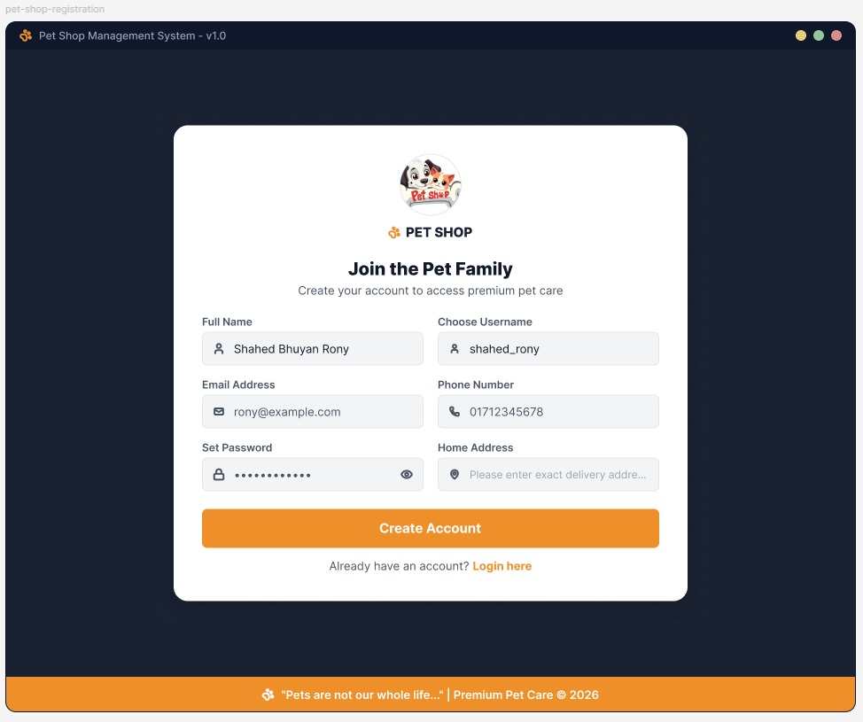
Registration Page

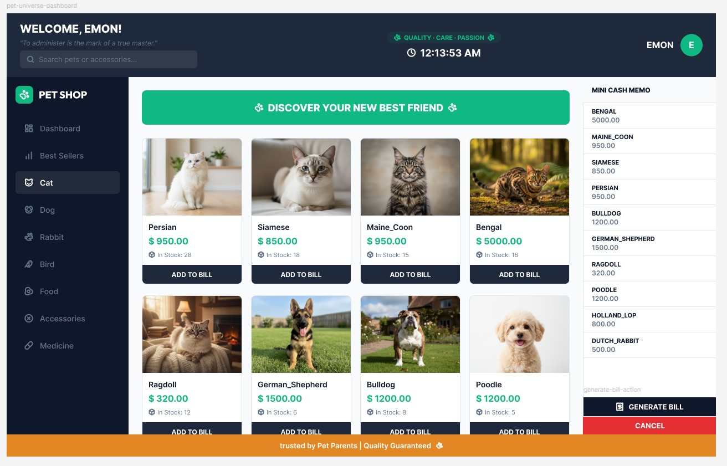
Customer Dashboard Page

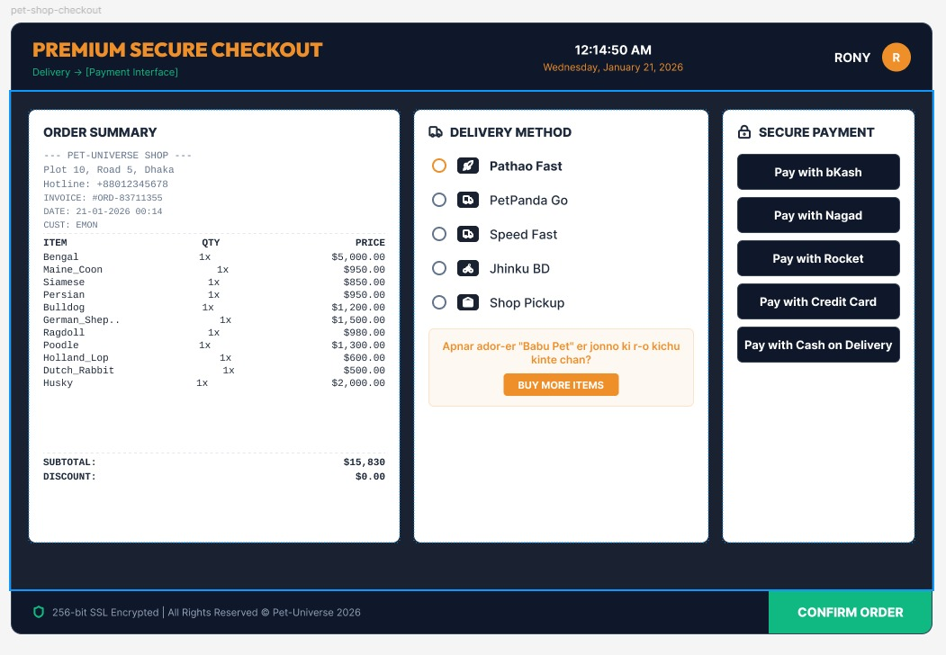
Payment Page


Admin Dashboard

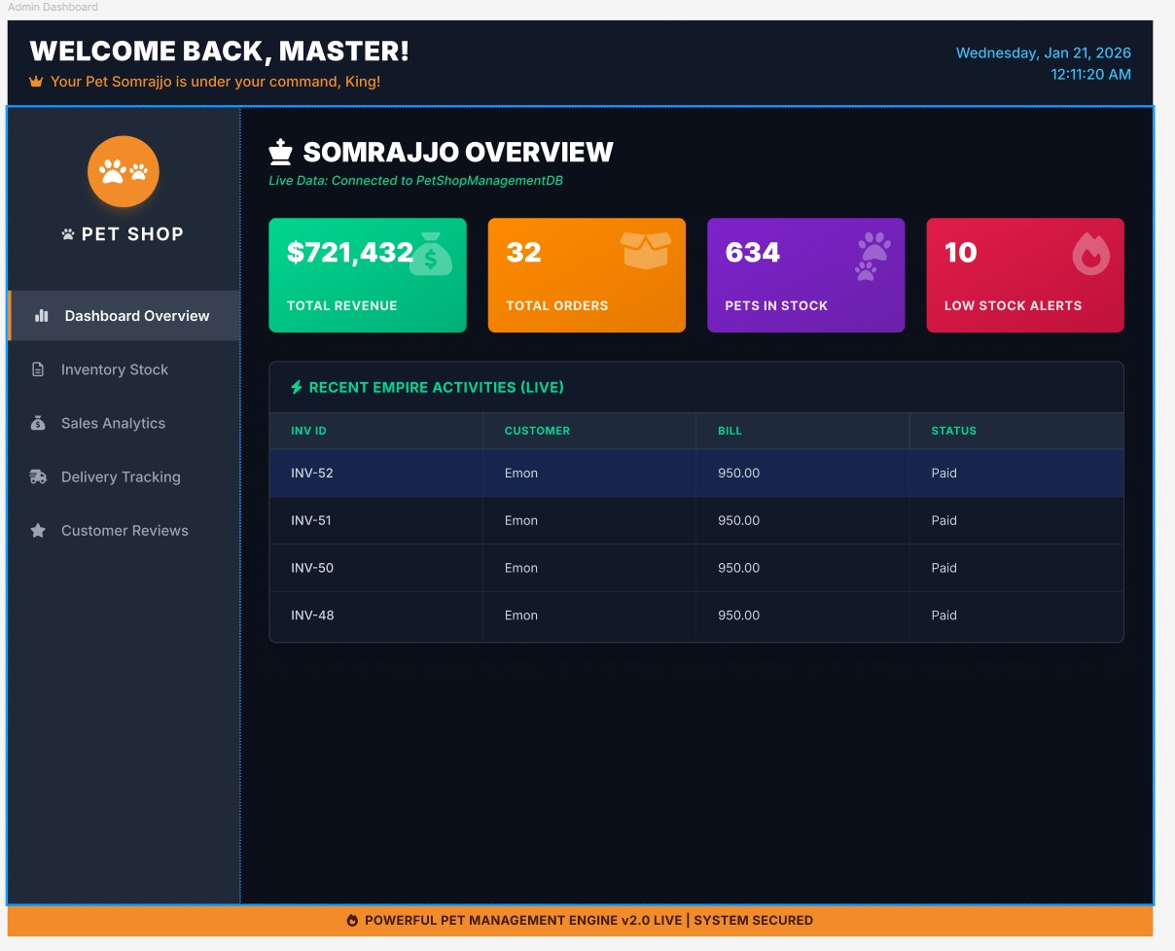
Admin Dashboard Overview
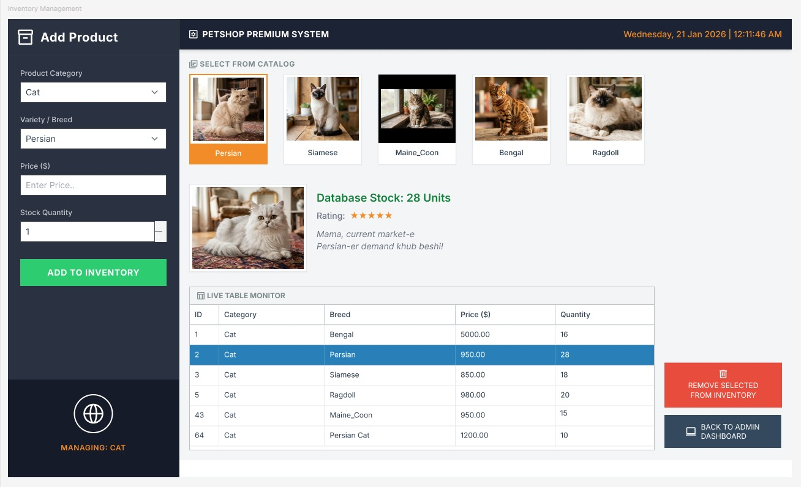
Admin Inventory Managment
TYPES OF USERS:
- User1: Administrator
The Administrator manages the overall system, including users, inventory, orders, veterinary services, and business operations.

- User2: Customer
Customers can browse pets and products, purchase items, book veterinary appointments, and track their orders.

- User3: Veterinary Doctor
Veterinary doctors manage appointments, maintain pet medical records, and provide consultation services.

- User4: Delivery Agent
Delivery agents receive assigned orders, update delivery status, and complete deliveries.

Common Features (Available to All Users)
- Authentication
- Login to the system
- Logout from the system
- User registration
- Account Management
- Change or reset password
- Manage profile information (view, edit, delete)
- Dashboard
- Access a personalized dashboard after login

SPECIFIC FEATURES BY USER TYPE
- Features of User1: Administrator
- Inventory Management: Add, Update, Delete Pets & Products.
- Order & Delivery Management: View Orders, Assign Delivery Agent, Update Order Status.
- User & Business Monitoring: Manage Users, View Reports, Monitor Sales Statistics
- Features of User2: Customer
- Browse & Purchase Pets and Products: Search, Filter, View Details, Add to Cart.
- Veterinary Appointment Booking: Book Doctor Appointment and View Appointment Status.
- Order Tracking & Reviews: Track Orders, View Purchase History, Submit Reviews
- Features of User3: Veterinary Doctor
- Appointment Management: View and Manage Daily Appointments
- Pet Medical Records: Create and Update Pet Health Records
- Treatment History: View Previous Medical History and Consultation Records
- Features of User4: Delivery Agent
- Assigned Order List: View Assigned Deliveries
- Delivery Status Update: Update Order Status such as Out for Delivery and Delivered.
- Delivery History: View Completed Deliveries and Delivery Performance

